ARBUTUS RIDGE COMMUNITY ASSOCIATION DECEMBER, 2014 NEWSLETTER
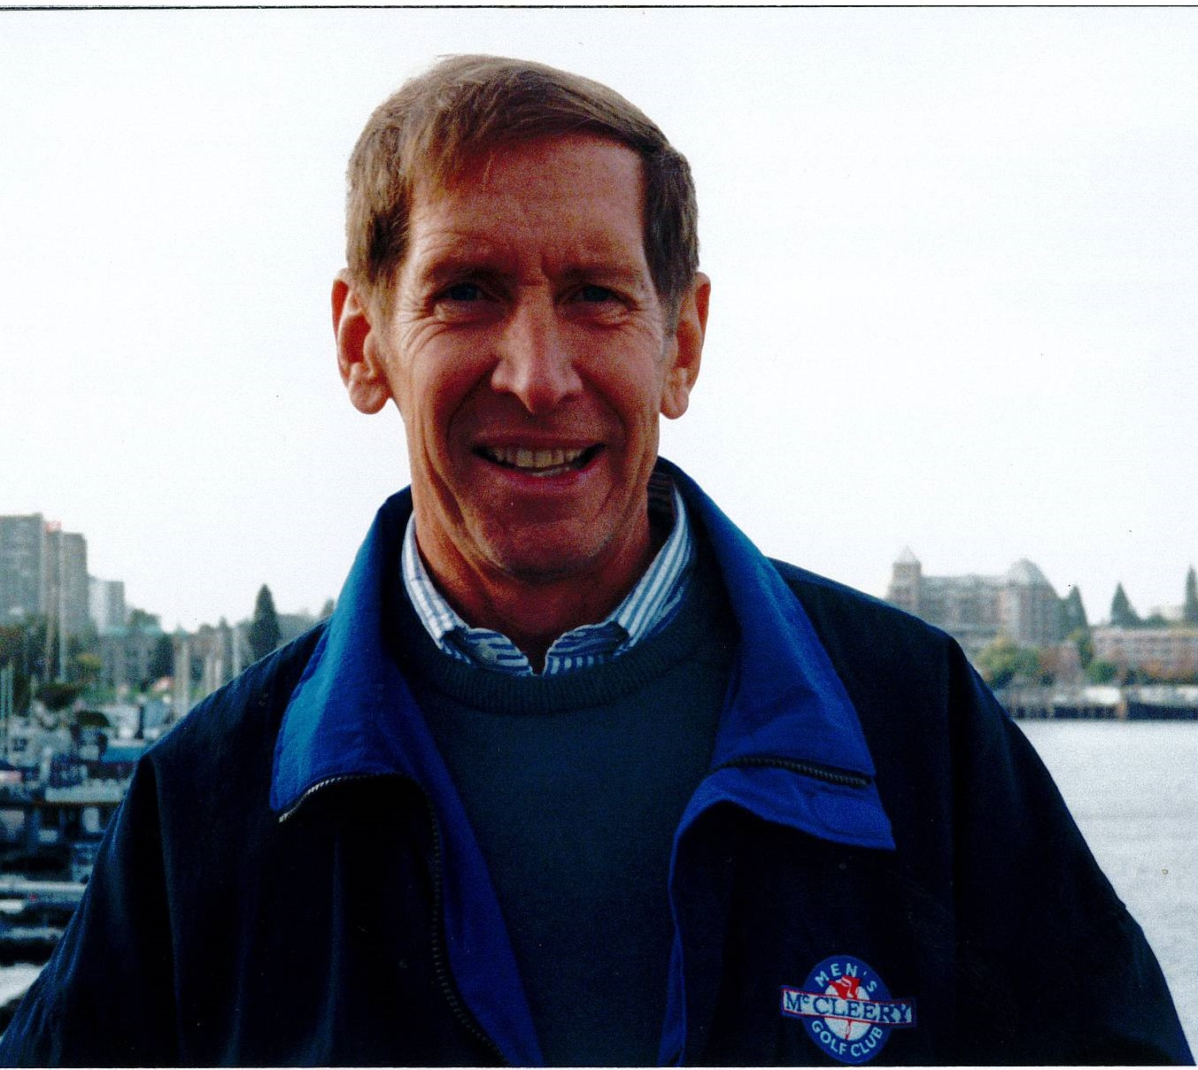
ARCA has lost one of its most supportive members – Jim Finch. Jim was on your executive, as vice-president, from its beginning in 2006. He also set us up and monitored ARCA on Twitter. Jim resigned from the executive last year, due to ill health, but said he would be back next year when he was better! During this year he assisted with sending out the newsletter by e-mail. As an engineer, Jim could fix anything and his friends and neighbours called upon him often! Jim is survived by a sister, two sons, one grandson, and the “love of his life for the past 20 years”, Jill Pennefather, also an ARCA member. We will miss you, Jim!
James Frederick Finch
May 2, 1941 – November 27, 2014

EDITORIAL ERROR! In our October newsletter, Arbutus Jewellers was listed as one of the businesses that had been given early notice to move for the redevelopment of the shopping centre. This was incorrect! Our apologies to owner, Andy Tan, and thanks for such giving us great customer service!
UPDATE ON THE ARBUTUS MALL: We were told, last summer, that the development permit would be applied for in November. Checking with City Hall, no permit has yet been applied for. The water problem has reportedly been solved, although many who live in the Village have complained about wet basements – and long before our recent rains. We are still pursuing a hydrologist to test our normal water levels so, in the event of the developer excavating for 3 or 4 parking levels, we will have proof if our water levels rise dramatically. The corner of Nanton and Yew is an interesting place to see when it rains. The large pond of water is not the result of a plugged drain; it is testimony of the water level in this marshy area. Amica recently added a lot of top soil to its Yew Street lawn but the grass is still extremely wet. Jim Hall, the president of ARKS, the City plan for Arbutus Ridge/Kerrisdale/Shaughnessy, suggested that we contact all the surrounding complexes and stratas to encourage them all to participate and share in the expense of hiring hydrology engineers. You could take this suggestion to your council if you have water-level concerns.
There is an upcoming vote by the Village stratas on the future of the recreation centre. The lease is up soon and they may not wish to renew. If the redevelopment proceeds as originally scheduled, the recreation centre would be demolished along with the old Safeway and mall. It was originally planned as part of Block C, the south west corner of the redevelopment which would not be built for at least 8 years, if at all. Larco had long ago announced that Block C would be built “if positive market conditions prevail”.
ARCA MEMBERSHIP: Membership Chair, Bill Haberl, and Treasurer, Marie Clarke, sent out letters to members delinquent with their 2014/2015 memberships. 30 members responded some with added donations. If you are not sure about your membership, please contact Marie Clarke at marieac@shaw.ca or phone her at 604-263-5086.
CONTACT US with your news and views at www.arbutusridgecommunity.org or arca@shaw.ca.
Merry Christmas, Happy Holidays and Happy New Year!

